PE Funding

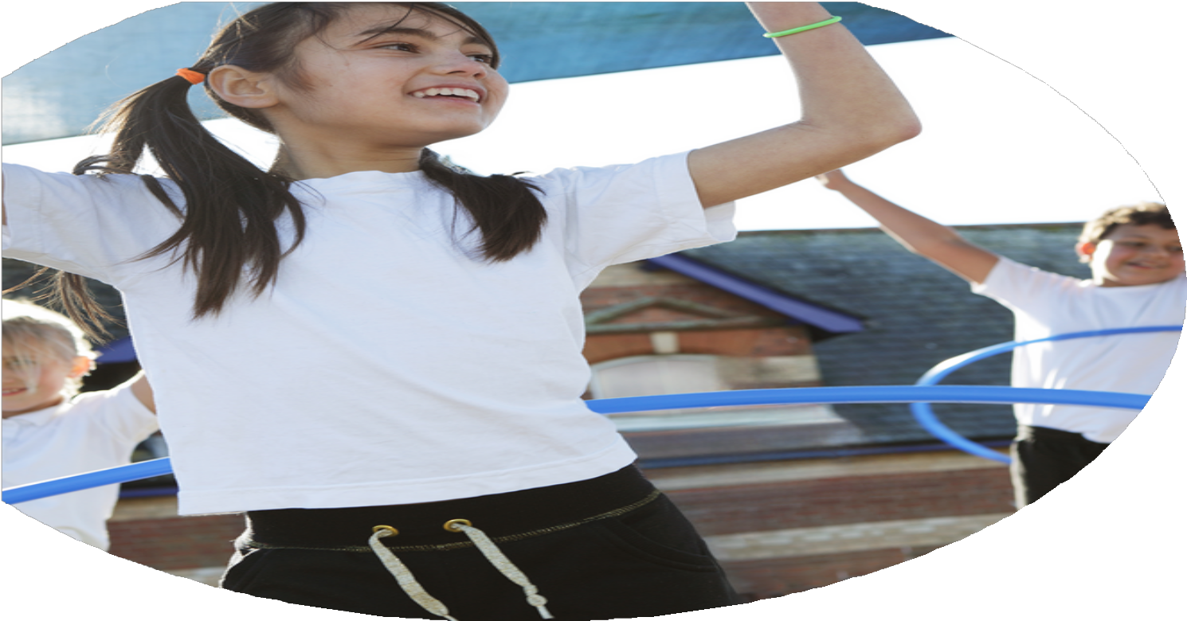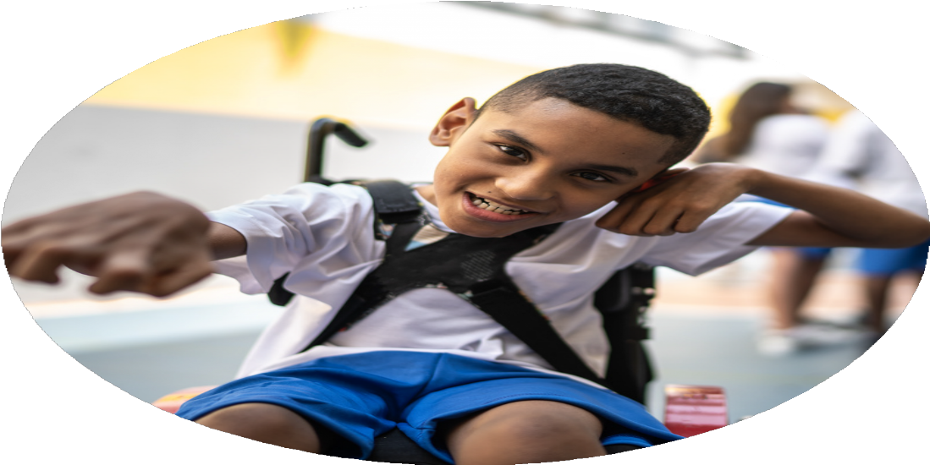

Evaluation Form

**Commissioned by**

**Created by**

Images courtesy of Youth Sport Trust

**PE Funding Evaluation Form**

 It is intended that this template should be used as preparation for the completion of the statutory digital reporting tool being introduced this academic year. You can upload data (including swimming) from this template onto this platform once it becomes accessible.

 Before you decide how you are going to use the funding for this academic year you should reflect and evaluate the impact of your use of the funding in 2023/24.

 All spending of the funding must conform with the terms outlined in the Conditions of Grant document.  The template is a working document that you can amend/update during the year.

 Based on your evaluation of last year’s funding you should decide what you intend to do this academic year, how you will do it, and what impact you expect it to have.

It is important that the funding is used effectively and based on your school’s needs.

 You must use the funding to make additional and sustainable improvements to the PE and sport in your school.  You must develop and add to the PESSPA activities that your school already offers.

*Summative digital reporting from June 2025 will continue to include swimming and water safety information therefore funding can be used to provide top-up lessons where necessary to ensure pupils meet national curriculum swimming requirements.*

Only used on sports day but want to have other sports events with in school.

Swimming data

Introduction of new sports house teams.

Swimming- the % of pupils leaving KS2 meeting the national swimming and water safety requirement

We have 6 breakfast clubs (2 on a Friday and 6 afterschool clubs (2 on a Monday).

% of girls taking part in a club:

24/25 = 63% (So far)

23/24 = 58%

22/23 = 36%

The number of breakfast and afterschool clubs that we offered our pupils

Separating some of our KS2 boys and girls clubs to increase girl participation in sports such as football and cricket.

PE Passport Scheme of Work to create and embed our PE curriculum. This has allowed us to link our units across year groups, that skills are progressive and differentiated across a range of sports.

Introduction of new clubs such as goalball, trigolf, kurling, boccia. More pupils attending new clubs that wouldn’t usually.

What are your plans for 2024/25?

Intent

How are you going to action and achieve these plans?

Implementation

**Key indicator 1** Increased confidence, knowledge and skills of all staff in teaching PE and sport

* To increase confidence of planning, managing and reporting PE and Sport Premium Funding and the new Digital Reporting Tool for SLT & Subject Leader.
* To increase knowledge and skills for Teaching Assistants by providing all staff with the opportunity to attend CPD to ensure we provide a High Quality Physical Education.

**Key indicator 2** The engagement of all pupils in regular physical activity

* To improve school resources and equipment to teach FMS for our young pupils in school including EYFS and KS1.
* To ensure that pupils are active on average for 60 minutes a day 7 days a week, this will include focusing on in school opportunities including breakfast, lunch and after school clubs.

**Key indicator 3** The profile of PE and sport is raised across the school as a tool for whole-school improvement

**Key indicator 4:** Broader experience of a range of sports and activities offered to all pupils.

* Develop and enhance our top-up swimming to raise the profile and standards of our swimming.

**Key indicator 5**: Increased participation in competitive sport.

* Continue to attend Preston School event, competitions and tournaments including taking more than one team.

Liaise with LPDS Jess Squires/ PESSPA Meetings to book onto courses which will provide guidance and support for new for Digital Reporting Tool and improving

‘New to Subject Leadership in Primary PE’. [Jan 2025] JR £200

‘Effective use of the PE and Sports Premium Funding for Primary Schools’ [June 2025] IG/JR £208 x2

‘Early Years PE Physical Development and Dance including FMS booklet’ SP £208

‘New to teaching KS1 PE’ [Jun 25] LW & AG £208 x2

‘New to teaching KS2 PE’ [Jun 25] BS KM SJ EM £208 x4 **£2072**

JR and Lancashire PE Consultent to complete an audit of PE equipment and resources specifically for EYFS/KS1 Fundamental Movement Skills e.g. *reaction balls, koosh balls, sensory bell balls, juggling scarfs, beach balls, large foam dice, skittle stands/Activity skittles, tail ball, large foam balls, spiky balls, balloon ball, heavy duty balloons, ribbons, bands*

£1000

Sports HLTA to continue to provide pupils with a broad range of breakfast, lunchtime and afterschool clubs to ensure as many pupils are provided with the opportunity to be physically active.

£6000

Book an extra swimming booster session at the end of the year taking the pupils who did not meet the swimming requirements.

Sports HLTA to track pupils representing school at events using PE passport and to take more than one team to some events.

What impact/intended impact/sustainability are you

expecting?

How will you know? What **evidence** do you have or

expect to have?

Completed and published on school website by 31st July 2025.

Staff confidence survey.

Pupil Voice via PE passport

PE passport register data.

PE passport event data.

By July 2025 SLT and Subject leaders are confident in reporting the PE and Sports Premium funding using the new digital reporting tool.

By Summer term 2025 EYFS, KS1 and KS2 Teaching Assistance feel confident in supporting the teaching of High Quality PE curriculum.

Improve the quality of EYFS and KS1 PE lessons through the use of a wide range of equipment and resources that best suit our pupils needs and to ensure that all pupils feel successful in their PE lessons.

That 60% of our pupils attend at least one club improving on last years 57%.

That there remains a close percentage % of girls and boys attending clubs and that some girls clubs remain gender specific.

That 40% of our pupils have the opportunity to represent school at an event, competition or tournament.

What **impact/sustainability** have you seen?

What **evidence** do you have?